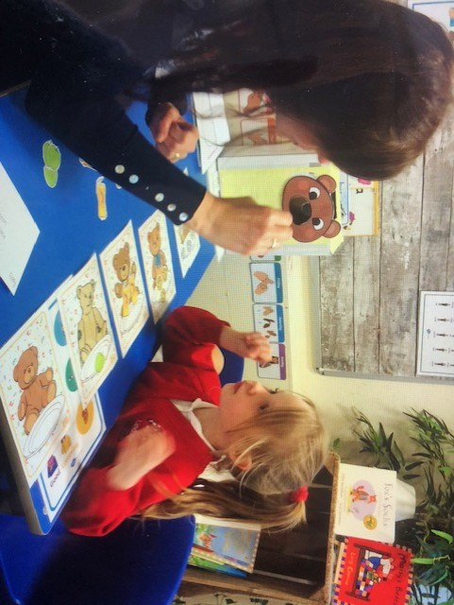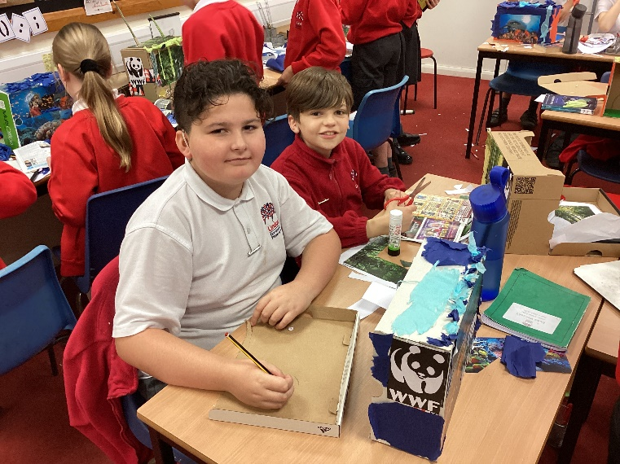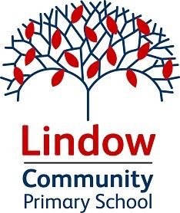

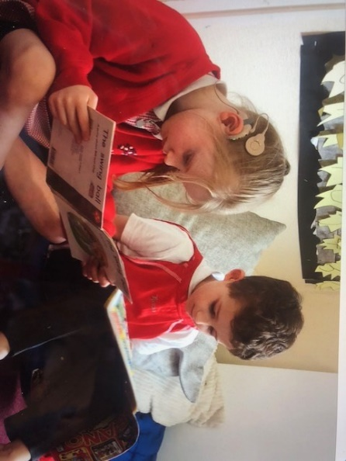

**Deaf Resource Base Provision**

**Handbook**

*Caring, learning and achieving together*

*Lindow Community Primary School Caring, learning and achieving together*

# Introduction

Welcome to Lindow’s Deaf Resource Base!

Lindow Primary School Deaf Resource Base is the resource provision for Deaf children of primary age in this part of Cheshire. We cater for children with a moderate, severe or profound hearing loss and we accept children with an Education, Health Care Plan (EHCP). The resource base is a purpose-built room, which is carpeted and acoustically treated to ensure the optimum listening conditions for deaf children. We currently have places for six pupils whose primary need is deafness. The children who attend the resource base are first and foremost members of their mainstream class, but need specialist teaching and support in order to develop language and fully access the National Curriculum.

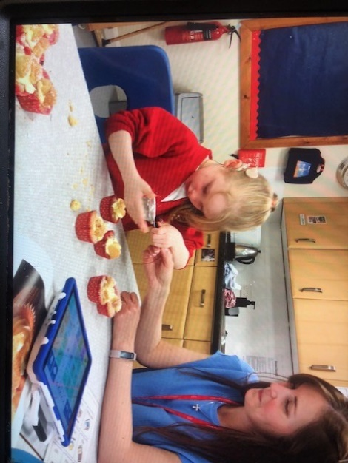The resource base is led and managed by a qualified Teacher of the Deaf. Additionally, the children are supported by specialist teaching assistants, both within their mainstream classes and in individual or small group teaching sessions in the resource base. This ensures that the children develop the language skills essential for access to the curriculum. The time spent in mainstream lessons will vary depending on the needs of the child and their ability to access mainstream teaching.

In the resource base, we use a total communication approach. For us, this means that whilst an auditory oral approach is most commonly used, we also provide additional clarification through the use of Sign Supported English (SSE). The Teacher of the Deaf and some of the teaching assistants hold BSL qualifications and have experience of working with children who use BSL as their primary communication mode.

The overall aim of our school is to provide a caring, secure and supportive environment in which all children make progress commensurate with their individual starting points and ability. This is achieved through specialist teaching and appropriate support.

Sharon Brown, Deaf Resource Base Manager

# A note from our Headteacher

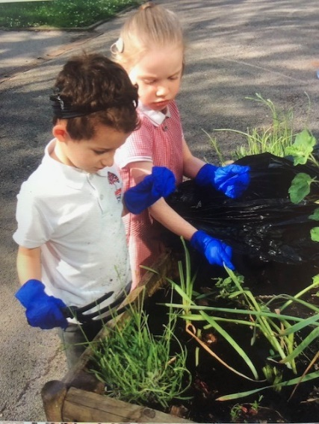The Deaf Resource Base Provision is an integral part of school. We are incredibly lucky to have this provision and the skilled and dedicated staff that are part of it, meaning the children make great progress in all walks of life and education. Fundamental to both the provision and wider school is the inclusive ethos that is carefully nurtured by all members of Lindow. Children are not either part of the Resource Base or part of Lindow Primary School, they are all part of Lindow Primary School but have the added component of an excellent specialist provision suited to their specific needs from an outstanding facility.

Tom O’Keefe, Headteacher

*Page* ***{*** *PAGE* ***}***

*HIRB Handbook*

## Aims and Philosophy of the Resource Base

* To facilitate access to a broad and balanced curriculum, through the use of specialist teaching and opportunities for inclusion into mainstream classes.
* To ensure the full involvement of deaf children in the life of the school.
* To facilitate language development, listening and other communication skills, through the use of spoken language and Sign Supported English if required.
* To develop a close working relationship with parents, in order to support and develop the needs of the child.
* To ensure that audiological management is of high priority, so that children have the best access to their learning environment.
* To ensure that children have the best auditory access possible through the regular care, maintenance and monitoring of audiological equipment.
* To facilitate the development of language and social skills, tracking these skills using specialist assessments.
* To provide a multi-disciplinary package of support, appropriate to each child’s needs. This may also involve external professionals.
* To liaise and work closely with external professionals, such as Paediatric Audiologists, Educational Audiologists, Speech and language Therapists, Auditory Implant teams and

Physiotherapists.

* To ensure that deaf children develop a positive self-image and feel valued members of the school community.
* To develop life and social skills within the wider community.
* To provide mainstream staff with deaf awareness training and are given guidance to support deaf children in their classes.

## Communication

In the Deaf Resource Base at Lindow, we primarily use an auditory-oral communication approach in order to facilitate the development of spoken language. There are some children who require additional clarification of the spoken word, through the use of sign language. For these children, a total communication approach is used. BSL (British Sign Language) signs are used alongside the English grammatical structure of spoken language. This is known as Sign Supported English

(SSE).

The Teacher of the Deaf and three of our specialist teaching assistants hold BSL qualifications.

## Deaf Resource Base Staff

Our HI team is led and managed by Mrs Brown, a qualified Teacher of the Deaf. In addition to this, we have a number of teaching assistants who specialise in working with deaf children. We also have close links with Macclesfield Paediatric Audiology Department, Manchester Auditory Implant Centre, Cheshire East Sensory Support Service and the NHS Speech Therapy Service.

## Support

All of the children in the Resource Base have support, which is timetabled to suit their individual needs. Support focuses on developing language skills and enabling access to the curriculum, where possible. This will involve 1:1 or small group work with the Teacher of the Deaf, as well as specialist teaching assistant support whilst in mainstream classes. In order to promote the children’s independence, there may be times or particular subjects when they are not supported.

## Audiology

The children’s equipment and any radio aid systems are checked every morning. This happens shortly after the children arrive in school, to ensure that they have the optimal auditory access to their learning environment. For more detailed information, please see our Audiology Policy.

|  |
| --- |
| *Lindow Community Primary School Caring, learning and achieving together* |

## Assessment, Recording & Reporting

Whole school strategies have been developed to monitor and track each child’s individual performance. Where needed, adaptations are made to reflect the child’s learning needs. Each deaf child will also have an EHCP Implementation Plan. These are used to focus on specific targets identified in the child’s Education, Health and Care Plan and they are written and reviewed termly. Parents are invited to contribute to these plans.

Additional assessment procedures include:

* Audiological assessments by the LA educational audiologist
* Language assessments to track language specific progress, which are administered internally.
* Speech and language assessments administered by the speech and language therapist.
* Other school-based assessments in line with the school’s assessment policy.

## Admissions Policy and Criteria

The Deaf Resource Base specialises in educating children with a moderate, severe or profound hearing loss, accepting those who have an Education, Health and Care Plan (EHCP).

Lindow Community Primary School,

Upcast Lane, Wilmslow, Cheshire SK9 6EH

Telephone: 01625 917269

Email: admin@lindow.cheshire.sch.uk

Web: www.lindow.cheshire.sch.uk

## Links with Parents

The school takes pride in the close links that is has with parents and we actively encourage the involvement of parents in their child’s education.

Throughout the academic year, there will be two Parents’ Evenings, where the progress of the child can be discussed with both the class teacher and the Teacher of the Deaf. In addition to these meetings, parents will also be given the opportunity to come into school each term to discuss their child’s EHCP Implementation Plan, if they so require.

Once a year, an Annual Review meeting will be held at school. The purpose of the Annual Review is to enable all parties to discuss the child’s progress over the year and agree targets for the forthcoming year.

Daily communication will be encouraged with parents/carers through the home/school diary or the Class Dojo communication portal. Parents are invited to participate fully in their child’s education by supporting them with their homework, with particular focus on the individual needs of the child.

## Secondary Transition

When considering secondary education, we aim to ensure a smooth transition, where appropriate support will already be in place before the child attends. Many children recently have continued their education at Wilmslow High School, where there is currently specialist deaf provision. Some children have attended other local mainstream secondary schools, with appropriate support from the local authority Sensory Inclusion Service.

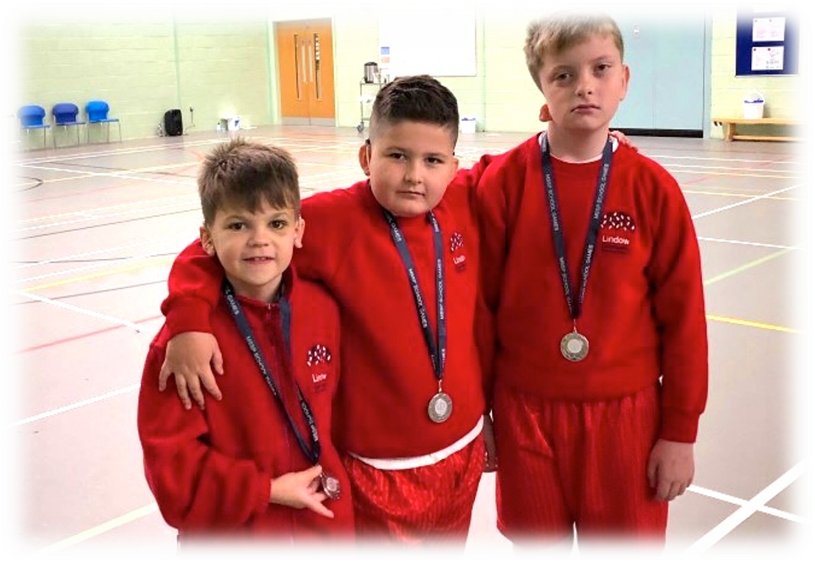

*Page* ***{*** *PAGE* ***}***