Deaf Resource Base Provision


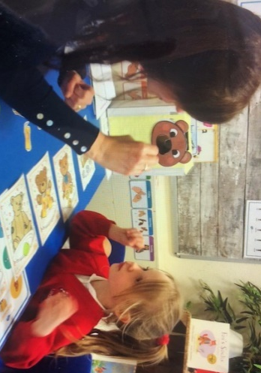
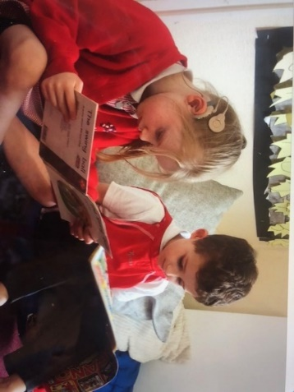
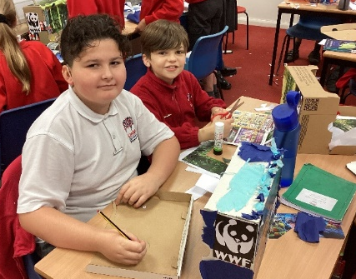
Introduction
Lindow Primary School Deaf Resource Base Provision is the resource base for deaf children of primary age in this part of Cheshire. We cater for children with a moderate, severe or profound hearing loss and we accept children with an Education, Health Care Plan (EHCP). The resource base is a purpose-built room, which is carpeted and acoustically treated to ensure the optimum listening conditions for deaf children. We currently have places for six pupils whose primary need is a deafness. The children who attend the Deaf Resource Base are first and foremost members of their mainstream class, but need specialist teaching and support in order to develop language and fully access the National Curriculum.
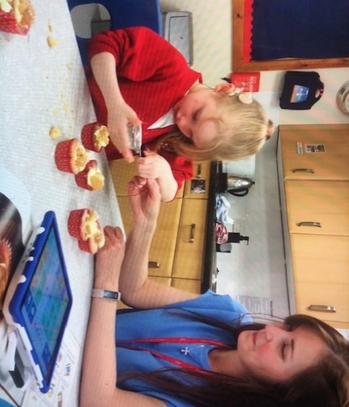
The resource base is led and managed by a qualified teacher of the deaf. Additionally, the children are supported by specialist teaching assistants, both within their mainstream classes and in individual or small group teaching sessions in the resource base. This ensures that the children develop the language skills essential for access to the curriculum. The time spent in mainstream lessons will vary depending on the needs of the child and their ability to access mainstream teaching.
In the resource base, we use a total communication approach. For us, this means that whilst an auditory oral approach is most commonly used, some children receive additional clarification through the use of Sign supported English (SSE). The teacher of the deaf and some of the teaching assistants hold BSL qualifications and have experience of working with children who use BSL as their primary communication mode.
The overall aim of our school is to provide a caring, secure and supportive environment in which all children make progress commensurate with their individual starting points and ability. This is achieved through specialist teaching and appropriate support.

Aims and Philosophy of the Resource Base
- To facilitate access to a broad and balanced curriculum, through the use of specialist teaching and opportunities for inclusion into mainstream classes.
- To ensure the full involvement of deaf children in the life of the school.
- To facilitate language development, listening and other communication skills, through the use of spoken language and Sign Supported English if required.
- To develop a close working relationship with parents, in order to support and develop the needs of the child.
- To ensure that audiological management is of high priority, so that children have the best access to their learning environment.
- To ensure that children have the best auditory access possible through the regular care, maintenance and monitoring of audiological equipment.
- To facilitate the development of language and social skills, tracking these skills using specialist assessments.
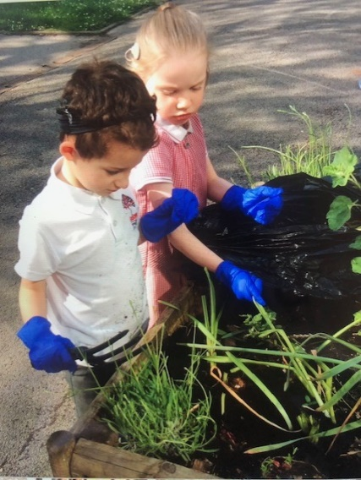
- To provide a multi-disciplinary package of support, appropriate to each child’s needs. This may also involve external professionals.
- To liaise and work closely with external professionals, such as Paediatric Audiologists, Educational Audiologists, Speech and language Therapists, Auditory Implant teams and Physiotherapists.

- To ensure that hearing-impaired children develop a positive self-image and feel valued members of the school community.
- To develop life and social skills within the wider community.
- To provide mainstream staff with deaf awareness training and are given guidance to support deaf children in their classes.

Assessment, Recording & Reporting
Whole school strategies have been developed to monitor and track each child’s individual performance. Where needed, adaptations are made to reflect the child’s learning needs. Each deaf child will also have an EHCP Implementation Plan. These are used to focus on specific targets identified in the child’s Education, Health and Care Plan and they are written and reviewed termly. Parents are invited to contribute to these plans.
Additional assessment procedures include:
- Audiological assessments by the LA educational audiologist
- Language assessments to track language specific progress, which are administered internally.
- Speech and language assessments administered by the speech and language therapist.
- Other school-based assessments in line with the school’s assessment policy, including small steps trackers.

